Number of Animals to be Tagged/Shown:
Each member may:
Tag Show
4 mkt. hogs 3 mkt. hogs in 4-H
4 mkt. lambs 2 mkt. lambs in 4-H
2 bucket calves 1 bucket calf in 4-H
4 Steers 2 steers in 4-H
4 Goats 2 goats in 4-H
**Extra market hogs, steers lambs and goats may be shown in open class.

Livestock Sale Weight Requirements
To be eligible for the premium sale livestock must weigh:
Beef and Dairy Beef Steers: Over 950 lbs.
Market Lambs: 90 to 150 lbs.
Market Hogs: 220 - 290 lbs.
Market Goats: 50-120 lbs.

2019 Market Steer Tag Day

The following are tag numbers and weight results from tag day. If you find errors please call the office.
- - not eligible for rate of gain

Exhibitor Tag # Weight
Chaplin 49663 624
Chaplin 49664 800
Chaplin 49665 932
Chaplin 49666 984
Cobb 33027 1012
Cobb 33031 916
Cobb 33032 940
Cobb 33033 552
Ivey 33037 982
Ivey 33038 1176
Newland 33035 672
Newland 33036 424
Newton 49667 714
Newton 49668 600
Newton 49669 658
Shinkle 49670 1088
Shinkle 49671 1040
Signer 49661 1064
Signer 49662 870
Smith 42015 574
Smith 33030 798
Smith 33029 918
Smith 33028 698
Springer 33039 834
Springer 33040 910
Wheeler 33034 758

May 2019 Tag Day Results
Please remember to pay for your tags if you did not pay on tag day!

- - not eligible for rate of gain

Bucket Calves
Exhibitor Tag# Beg-Wt
Bosch, Brayden 22 --
Boss, Wyatt 26 138
Boss, Wyatt 27 244
Compton, Carliegh 35 132
Compton, Chloe 36 148
Eisele, Noel 25 78
Estes, Hazel 31 336
Francis, Tatum 21 182
Francis, Tatum 24 184
Kebert, Hunter 30 118
McCormick, Eli 29 --
Springer, Cooper 23 ---
Vorhees, Morgan 32 --
Vorhees, Morgan 33 --
Wheeler, Cashton 34 --

Goats FFA/4-H Market Goats
(D) Dairy Goats
Exhibitor Tag# Beg-Wt.
Alexander 62163 50
Alexander 62164 36
Alexander 62165 42
Alexander 62166 28
Boss 44777 30
Boss 44778 16
Cobb 30960 28
Cobb 44761 32
Cobb 44762 48
Cobb 44763 64
Coulter 44766 34
Coulter 44767 28
Coulter 44768 36
Coulter 44769 28
Coulter 44770 28
Coulter 44771 42
Coulter 44772 50
Coulter 44773 38
Coulter 44774 36
Crownover 62176 30
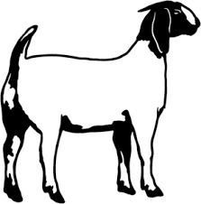
Ferro 62179 50
Ferro 62180 38
Ferro 62181 28
Frenk 44775 36
Hyler 44779 40
Hyler 44780 54
Jimenez 62161 52
Jimenez 62162 50
Kebert 62172 20
Kimzey 44776 44
Leck 44764 --
Leck 44765 --
Newland 62170 --
Shinkle 62167 50
Shinkle 62168 60
Shinkle 62169 56
Weaver 62172 34
Weaver 62173 36
Weaver 62174 36
Weaver 626175 36
Wheeler 62177 34
Wheeler 62178 54

Sheep FFA/4-H Market Lambs
Exhibitor Tag# Beg-Wt.
Cobb 41977 90
Cobb 41978 70
Cobb 41979 60
Cobb 41978 48
Cobb 58383 62
Couch 58390 64
Eaton 55403 56
Erbe 58384 66
Erbe 58385 82
Ghramm 57222 60
Ghramm 58381 56
Ghramm 58382 74
Newland 58386 50
Newland 58387 60
Newland 58388 66
Newland 58389 46
Newland 58391 46
Newland 55392 24
Newland 55393 22
Newland 55394 20
Wheeler 55395 24
Wheeler 55396 22
Wheeler 55399 58
Wheeler 55400 82
Wheeler 55401 54
Wheeler 55402 74

Swine-FFA/4-H Market Hogs
Exhibitor Tag# Beg-Wt.
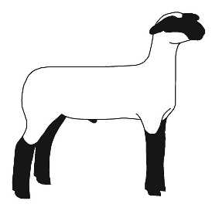
Bosch 55715 --
Bosch 55716 --
Bosch 55717 --
Chaplin 55728 156
Chaplin 55729 104
Chaplin 55730 120
Chaplin 55731 134
Chaplin 55732 98
Chaplin 55733 82
Cobb 36994 108
Cobb 36995 140
Cobb 55701 88
Cobb 55702 84
Cobb 55703 114
Cobb 55704 94
Cobb 55705 98
Eisele 55718 46
Eisele 55719 34
Evans 55747 106
Evans 55748 86
Ghramm 55725 86
Ghramm 55726 66
Leck 55706 --
Leck 55707 --
Leck 55708 --
Leck 55709 --
Leck 55710 --
Leck 55711 --
Leck 55712 --
Leck 55713 --
Leck 55714 --
Newland 55741 52
Newland 55742 54
Newland 55743 88
Reaves 55737 160
Reaves 55738 156
Reaves 55739 142
Reaves 55740 54
Sandbothe 55720 148
Sandbothe 55721 98
Sandbothe 55722 88
Sandbothe 55723 126
Sandbothe 55724 84
Signer 55744 100
Signer 55745 142
Signer 55746 130
Vorhees 55749 86
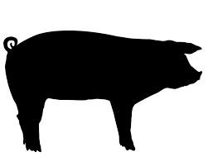
Vorhees 55750 68

