|  |  |  |
| --- | --- | --- |
|  | |  |
| **| May | 2020** | | |
| Thank you! **Thank you to everyone for your patience during this pandemic. Please let us know if you need anything.**  **Please note that fair will be live unless something drastic happens we do have a plan B.** |  | Inside This Issue  PG. 2  Calendar of Events  PG. 3  Discovery Days: Steer Tag Day: Fair Entry: Livestock Club: Livestock Judging  PG. 4  Horse Show: Geology Day: Fair Promotion  **PG. 5**  **Ice Cream Social: Royalty Contest**  **PG. 6**  **Herdsmanship Contest: Poultry Testing:** |

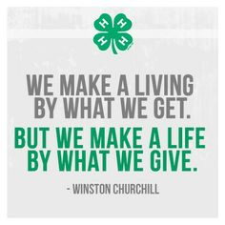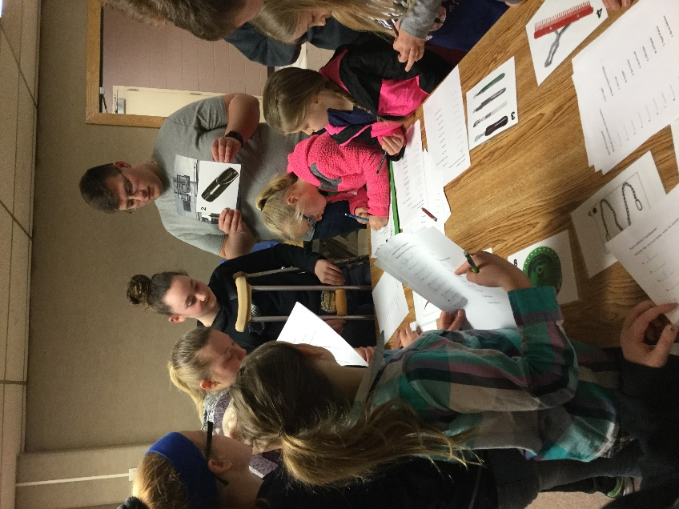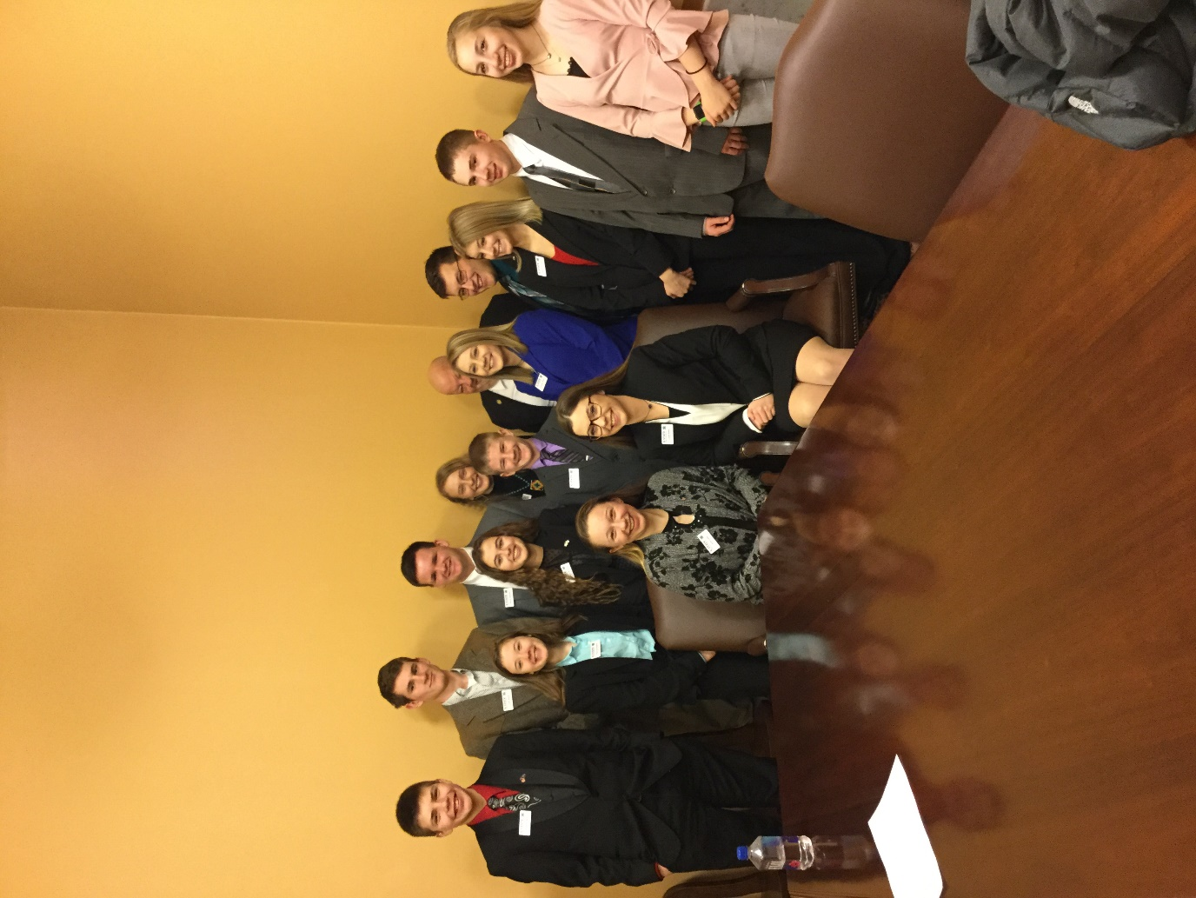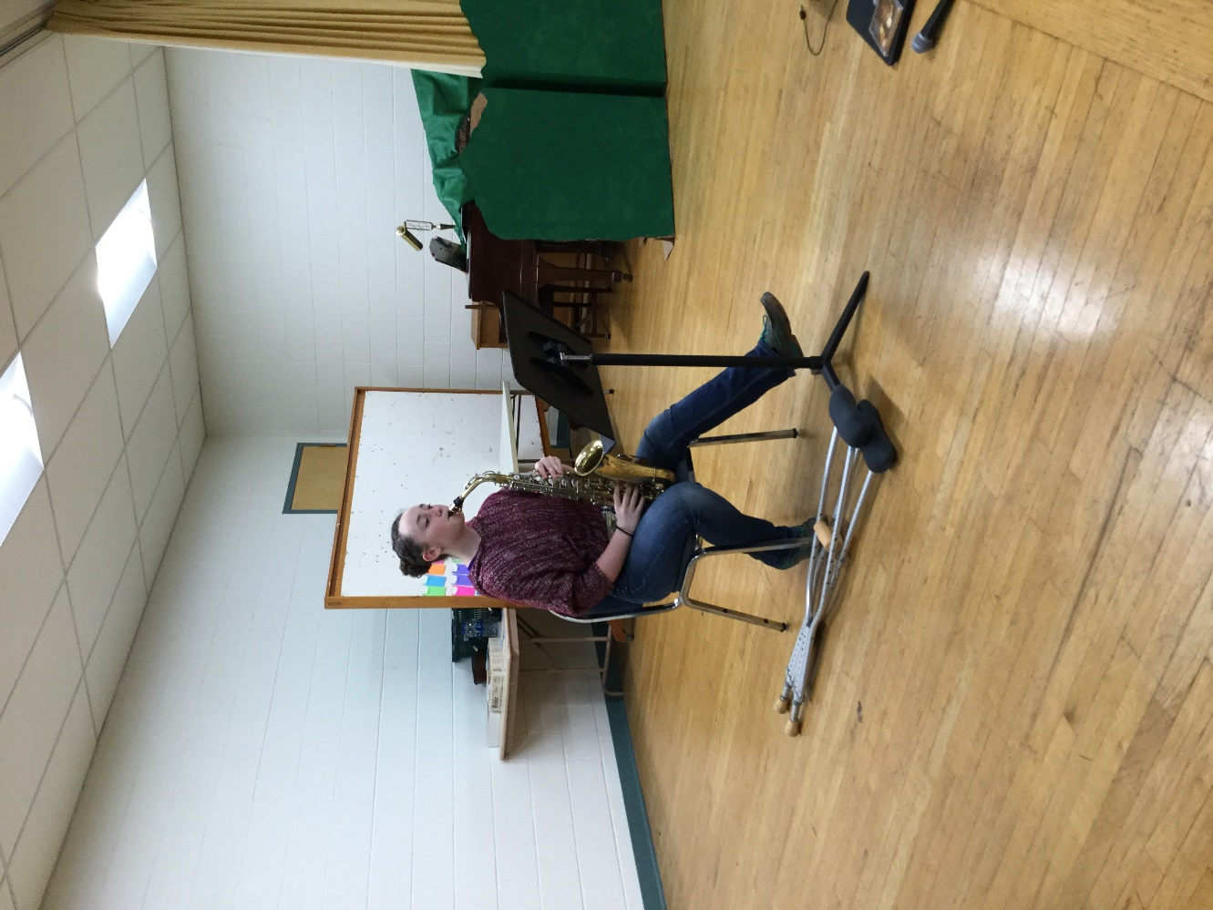

|  |  |  |
| --- | --- | --- |
| Calendar of Events **May 2020**  1 New Member deadline to exhibit at fair  1 Horse ID papers  18 4-H Council Zoom Meeting  25 Office Closed  **June 2020**  2 Favorite Foods Virtual Contest  **July 2020**  4 Office Closed  17 Style Review and Clothing Judging  19 Clean up and Set up for Fair  20 Foods Judging  22-26 Wilson County Fair Events |  | **Dear 4-H members, parents, leaders, and friends,**  **We are starting to get back into the busy season so read the calendar carefully! If you are interested in attending any virtual contests, please reach out to us! We can help coordinate with you.**  **Sincerely,**  **Cheri and Miranda**  2019-20 4-H Club Assignments  Club Day Soup Supper: Homebuilders  Ice Cream Social: 4-H Council Finance Committee  Dinner/Auction Fundraiser: Lucky Horseshoe  Achievement Banquet: High Prairie  Style Revue: Busy Beavers |
| **Wildcat Extension District – Crawford County 4-H Website**: www.wildcatdistrict.k-state.edu/4-h/crawford/  **Find us on Facebook** @ Wildcat Extension District &  @ Wildcat Extension District 4-H |  |  |

*Kansas Jr. Livestock Show*

The KS Junior Livestock Show will be September 27-29 at the State Fairgrounds in Hutchinson. Entry fees: Market Steers $35, Breeding Heifers $10, Barrows $15, Market lambs $15, Breeding Ewes $10, Meat Goats $15.00 and Commercial Heifers $15.00 (fees may change). If you plan to exhibit market sheep, market pigs or commercial heifers you will need to fill out identification forms prior to June 15. Late nominations will not be accepted.

Discovery Days

Discovery Days will be offered virtually if you signed up. Be watching for more information on this in the near future.

*Livestock Identification*

Contact the Extension Office if you wish to tag market sheep or swine for the KS Jr. Livestock Show or the State Fair in Hutchinson. The market hogs, market lambs and market goats must be tagged by June 15th. In addition, you will need your pigs, your lambs and goats’ DNA tested.

*Area Judging contest & Favorite Food Show*

*4-H Council Meeting*

The next 4-H council meeting is scheduled for Monday, May 18, 2020 at 6:30 PM via Zoom. Representatives please plan to attend or a representative from your club.

We are working on how to offer these contests virtually so please be watching for more details.   
The Southeast Area Judging Contest for Crops, Photography, Horticulture, FCS and Favorite Food Show will be held June 3rd in Emporia. If you are interested in attending, please call the Extension Office and let us know.

*FairEntry*

For the 2nd year, the Wildcat District will be the use of FairEntry system. FairEntry is a system that is designed to improve overall flow and efficiency of the fair. The use of this system will mainstream a variety of areas such as class entry (at county and state level), tracking livestock information, and even the livestock sale. The system is integrated with 4-H Online which makes it easy for families to access their information and keep organized. The use of this system district wide will not only create more time but also resources for greater more impactful programs.

*District Horse Show*

*Entries Due*

There will not be a District Horsehow this year. If you are 9 before Jan 1st you can enter the State fair, there is a level 1 horse test you need to complete and I need to send your ID papers to the State Office. Please let us know if you want to do this.

*Questions?*

If you have any questions about activities listed on the calendar or mentioned in the newsletter, or about Fair Entry - Please ask us in the Extension Office! You might also try looking through the Fair Paper or your last newsletter, or ask your project or community 4-H leaders.

*4-H & Fair Promotion*

WE WILL STILL DO THIS IF ALLOWED IN JULY!  
Anyone interested in doing a radio spot for 4-H and the fair, we will record some spots sometime in July. If you want to do this write a short (30 second) announcement about your project. You will want to mention something about coming to the fair to see it. If you don't want to write one let Cheri know and she will have one ready for you. This is good for members applying for Key Award.

*Club Responsibilities During the Fair*

1. In charge of Baked Food Sale at time of 4-H judging- Busy Beavers
2. In charge of Baked Food Sale at the Fair- Busy Beavers
3. Sweep the Pratt and Porter Buildings daily during the fair and pick up trash around the buildings and rest rooms daily during the fair- Homebuilders and Office.
4. Unlock and Lockup Buildings, raise and lower flags, distribute trash Barrels-High Prairie Pioneers & Lucky Horseshoe.

*2020 Clean-Up Day**Assignments*

Clean-up: **Sunday, July 19th at 2:00 pm. Supplies to Bring: Weed eaters, rakes, shovels, forks, garden hoses, post driver, brooms, rags and buckets, dish washing soap.**

Clean-up Assignments 2019:

**Barns-** Lucky Horseshoe & High Prairie Pioneers **Building-** Homebuilders & Busy Beavers

*Fair Superintendents*

We would like to encourage those 4-H parents who are also Fair Superintendents to help their 4-H'ers enter their exhibits **before** check-in time. (Place items for entry in that area where they are usually entered with slip of paper with name and class attached). It is important that you are at your area to help others enter at entry time.

*Fair Booth Set Up*

**Booths may be set up on Wednesday, July 22nd from 10:00 am - 5:00 pm and Thursday, July 23rd from 9:00 am - 5:00 pm. Booths must be in place by Thursday evening at 5:00 pm.**  This will include all 4-H Club Booths, Project Booths, WEC Booths. Arrangements may be made with the Extension Office to set up on Wednesday evening during the Horse Show if necessary by contacting the office.

*Ice Cream Social*

The Ice Cream Social will be **Saturday, July 25th** at 1:30 p.m. near the Davie's Arena. Two people from each club will be needed to help serve. These people should be there at 1:00 pm. **The 4-H Council Finance Committee is in charge.**

**GALLONS/CAKES REQUIRED:**

Busy Beavers 5 gal./3 cakes

High Prairie Pioneers 5 gal./3 cakes

Homebuilder’s 5 gal./3 cakes

Lucky Horseshoe 5 gal./3 cakes

Take to B-W Processing Plant the day before, so it can be completely frozen before serving, OR bring from your home freezer just before. Let the office know where your ice cream is if you do something else. Also, **please bring in a wide-mouth container for easier serving. Pick up your ice cream freezers or containers after the social or arrange for someone else to pick it up. Thanks.**

**JUST A REMINDER: If you have a 4-H shirt we would like you to wear it during the Ice Cream Social.**

*4-H Royalty Contest*

During the fair, Wilson County 4-H Junior Leaders will sponsor a 4-H Royalty Contest to select a 4-H King and Queen, and Prince and Princess. The Wilson County 4-H King and Queen will reign from July of this year through July of next year. These two people will be elected by a penny a vote system during the County Fair. The person(s) who accumulate the most votes win the Royalty Contest.

The 4-H King and Queen, and Prince and Princess will participate in 4-H promotional activities throughout the year to encourage more people to participate in 4-H. A list is available in the Extension Office.

*Rules for 4-H Royalty Contest:*

1. Each club is asked to nominate 1 King, 1 Queen, 1 Prince and 1 Princess to participate in the election. King and Queen nominees must be at least 12 years of age as of January 1st of the current year. Prince and Princess nominees must be ages 7-11 as of January 1 of the current year. A person may not serve two consecutive years in the same royalty role.

2. Each club must decorate their own cans to receive votes for each candidate. Each club needs 4 cans, 2 for the boys and 2 for the girls. The Club President and Vice President from each club will be sure the cans are decorated.

3. **Voting for Royalty will take place at these events: Candidates may place 3 CANS at local businesses starting July 1st until the 24th. One can will be placed at the Fair from Thursday evening, July 25th at 6:00 pm until Sunday at noon.** The Royalty will be crowned at the trophy presentation Monday evening.

*Fair Paper*

The Wilson County Fair Paper will be posted on the website. Be sure to read this paper carefully to catch-up on any new rules or schedule changes.

*Photography and Arts and Craft Consultation Judging*

Judging for both of these projects will take place on ***Thursday, July 23rd at the fairgrounds***. Photography will begin at 9:00 am. Arts & Crafts will start at 9:00 am. Times will be assigned. Photography will be judged on a schedule by club to be determined later.

*Herdsmanship Contest*

A herdsmanship contest will be part of the selection of the club that wins the clean barn award at the fair. Members are encouraged to keep their livestock pens clean and decorate them to make them attractive. **No Christmas-type lights will be allowed because of safety considerations.** The contest will be judged with the **major emphasis on cleanliness** and less emphasis placed on the attractiveness of decorations.

**Encourage your fellow club members with livestock to plan for a neat exhibit now! Let's make our livestock barns as clean and appealing to the public as we can and show that 4-H is a great program!**

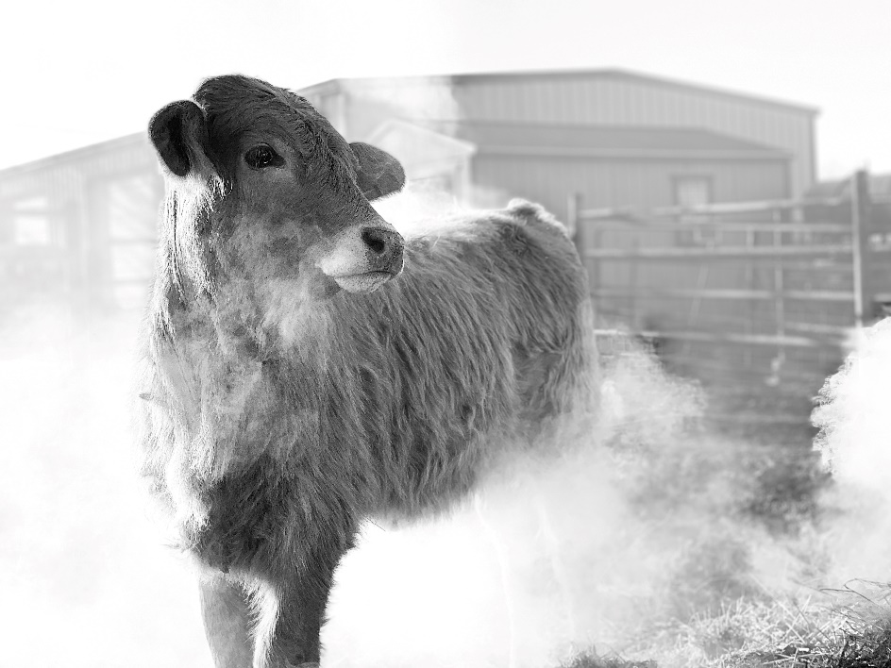

*Livestock Fair Information*

**Livestock may be brought to the Fairgrounds on THURSDAY EVENING** OR **FRIDAY MORNING** **AT SPECIES WEIGH IN TIME**

Hogs, 7:30 – 8:30 am

Sheep/Goats, 8:30 – 9:30 am

Beef/Bucket Calves, 9:30 – 10:30 am

***Livestock must be in place by the end of the species weigh in time!***

Scales may be used Thursday night for unofficial weight. It will be your responsibility to “0" the scales.

*Number of Animals to be Tagged/Shown:*

Each member may:

Tag Show

4 mkt. hogs 3 mkt. hogs in 4-H

4 mkt. lambs 2 mkt. lambs in 4-H

2 bucket calves 1 bucket calf in 4-H

4 Steers 2 steers in 4-H

4 Goats 2 goats in 4-H

**Extra market hogs, steers lambs and goats may be shown in open class.

*Premium Sale Regulations:*

**A 4-H member must attend two of the four County Livestock Project Meetings to be eligible for the 4-H Premium Sale.** **There is only one meeting left!!!!!**

*Livestock Sale Weight Requirements*

To be eligible for the premium sale livestock must weigh:

Beef and Dairy Beef Steers: Over 950 lbs.

Market Lambs: 90 to 150 lbs.

Market Hogs: 220 - 290 lbs.

Market Goats: 50-120 lbs.