K-State
Extension Connection

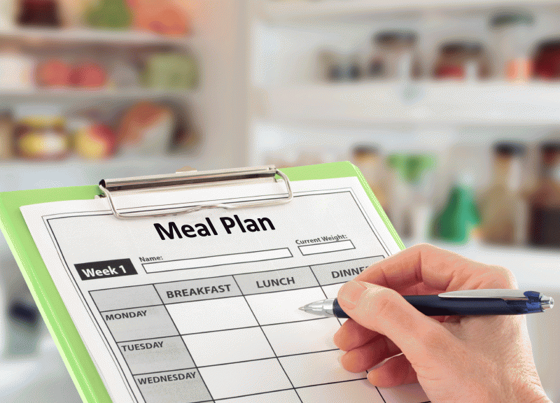
PLAN…To Save Time and Food Dollars
Barbara L. Ames
Wildcat District Extension Family and Consumer Sciences Agent

Do you ever get tired of running to the grocery store several times each week? Do you ever get frustrated because you forget about a food and it spoils before you can use it? Do you want to save money on your food budget? If so, menu planning is for you.

To plan a menu for your family, start by picking a length of time that works best -- usually a week is a good place to start. Write down your meals and snacks on a dry-erase board, calendar, notebook, piece of paper, app, worksheet or whatever works best for your family. Using your menu plan, write your grocery list and you are ready to go shopping.

5 SIMPLE STEPS...
1. Check your refrigerator, freezer, and pantry to see what you already have. You can build a meal around something simple you already have. For example, if you have a lot of frozen vegetables, plan meals such as soups and casseroles that you can stir frozen vegetables into.

2. Check weekly grocery ads to see what is a good deal. Using sale items in your menu can help you save money. If you see blueberries are a good deal, plan blueberries as snacks, blueberry muffins for breakfast, and a fruit pizza with blueberries for dessert. If they are a really good deal, freeze some for another day.

3. Keep a list of family favorites. List meals and snacks that your family likes and use the list when you have a hard time thinking of meals.

4. Plan to have leftovers. You can make a double batch of something one night and serve it again another night. This works well if you know you have a busy night coming up and will not have time to cook.

5. Be flexible. Think of simple things to stock for breakfast, lunch, and snacks—especially if your family is on the go with work and school. Then put more planning into supper, a meal you can sit down and enjoy as a family.

To review an example menu plan for a week, more shopping tips, lots of great recipes and more, check out Iowa State University’s Spend Smart. Eat Smart. web site at www.extension.iastate.edu/foodsavings/recipes/all.

Menu planning is a fantastic way to keep your family budget on track. It helps save money on groceries, makes sure your family is getting the nutrition they need, and saves time with deciding on meals and preparation.

For more information about this topic or other topics, contact the Wildcat Extension District offices at: Crawford County, 620-724-8233; Labette County, 620-784-5337; Montgomery County, 620-331-2690; Wilson County, 620-378-2167; Pittsburg Office, Expanded Food and Nutrition Education (EFNEP), 620-232-1930. Wildcat District Extension is on the Web at http://www.wildcatdistrict.ksu.edu. Or, like our Facebook page at facebook.com/wildcat.extension.district.

K-State Research and Extension is an equal opportunity provider and employer.

-30-

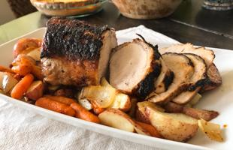
PORK LOIN ROAST AND VEGETABLES
Serves 6

A perfect recipe for meat and potatoes fans. Enjoy this recipe with a fresh side salad, and a piece of fruit for dessert.

Ingredients
2 cups onions, cut in wedges (about 1/2 pound or 2 medium )
2 cups potatoes, diced (about 12 ounces or medium)
2 cups baby carrots (or 3/4 pound regular carrots, sliced)
2 tablespoons vegetable oil (divided)
1 1/4 pounds pork loin

For Rub:
3 teaspoons brown sugar (1 Tablespoon)
1/2 teaspoon garlic powder
1/2 teaspoon pepper
1/4 teaspoon salt

Directions
1. Preheat oven to 400°F.
2. In a bowl mix veggies with 1 tablespoon oil, salt, and pepper.
3. Lay veggies around the edge of a 9"x13" pan and put in oven.
4. Use a small bowl to make the rub. Mix the brown sugar, garlic, 1/2 teaspoon pepper, and 1/4 teaspoon salt in the bowl.
5. Sprinkle the rub over the loin. Press gently so the rub sticks to the roast. Wash your hands after handling the raw meat.
6. Heat the remaining 1 tablespoon vegetable oil in a large skillet over medium high heat. Add the loin. Brown the sides of meat. Turn after about 2-3 minutes per side.
7. Transfer the pork to the center of the pan with veggies. Bake for about 40 minutes. A meat thermometer should read 145°F. Check the temperature after 30 minutes in the oven.
8. Remove from oven. Let set for 5 minutes. Slice and serve.

Notes:
-Wash and cut potatoes and onion into chunks about the same size as baby carrots.
-Use a meat thermometer. Cooked pork can be pink even when the meat has reached a safe temperature.
-For safety and quality, allow meat to rest for at least three minutes before slicing.

Nutrition Facts: Serv. size: 3 oz. meat and 1 cup vegetables, Amount per serving: Calories 225; Total Fat 10g; Sat. Fat 2g; Trans Fat 0g; Cholesterol 44mg; Sodium 171mg; Total Carbohydrate 19g; Dietary Fiber 3g; Total Sugars 6g; Added Sugars included 1g; Protein 16g; Vitamin D 0 IU; Calcium 39mg; Iron 1mg; Potassium 597mg.

Source: Iowa State University Extension. Spend Smart. Eat Smart

