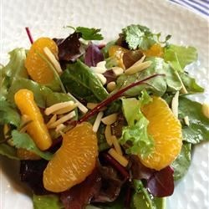
Orange-Almond Salad
Serves 4

Ingredients
3 cups assorted salad greens
2 navel oranges, peeled and sectioned
½ cup celery, thinly chopped
2 tablespoons green onion, chopped
¼ cup cider vinegar
¼ cup Splenda
2 teaspoons olive or canola oil
¼ cup toasted slivered almonds
¼ cup dried cranberries (optional; not in nutrition information)

Directions
1. Combine salad greens, orange sections, celery, and green onions in a large bowl.
2. Combine vinegar, Splenda, and oil in a small mixing bowl; stir until well blended. Drizzle over greens immediately before serving.
3. To serve, garnish with toasted almonds and dried cranberries (if desired). Serve immediately.

Nutrition Information: Per 1½ cup Serving: Calories 110, Total Fat 6g (Saturated Fat 0g, Trans Fat 0g) Cholesterol 0mg, Sodium 25mg, Total Carbohydrate 14g (Dietary Fiber 4g, Sugars 8g), Protein 3g.

Source: Dining with Diabetes—West Virginia University Extension Service, 2003

